
Semester One

Examination 2022

Question/Answer booklet

PHYSICS
UNIT 3

Name: _______________________________________________________

Teacher: ___________________________________________________

TIME ALLOWED FOR THIS PAPER

Reading time before commencing work: Ten minutes
Working time for the paper: Three hours

MATERIALS REQUIRED/RECOMMENDED FOR THIS PAPER

To be provided by the supervisor:
- This Question/Answer Booklet; Formula and Constants sheet

To be provided by the candidate:
- Standard items: pens, pencils, eraser or correction fluid, ruler, highlighter.

- Special items: Calculators satisfying the conditions set by the SCSA for this subject.

IMPORTANT NOTE TO CANDIDATES
No other items may be taken into the examination room. It is your responsibility to ensure that you do not have any unauthorised notes or other items of a non-personal nature in the examination room. If you have any unauthorised material with you, hand it to the supervisor before reading any further.

Structure of this paper

Section | Number of questions available | Number of questions to be answered | Suggested working time  (minutes) | Marks available | Percentage of exam
Section One:  Short Response | 11 | 11 | 50 | 54 | 30
Section Two:  Problem Solving | 7 | 7 | 90 | 90 | 50
Section Three:  Comprehension | 2 | 2 | 40 | 36 | 20
 |  |  | Total | 180 | 100

Instructions to candidates

- The rules for the conduct of Western Australian external examinations are detailed in the Year 12 Information Handbook 2022. Sitting this examination implies that you agree to abide by these rules.

- Write your answers in this Question/Answer Booklet.

- When calculating numerical answers, show your working or reasoning clearly. Give final answers to three significant figures and include appropriate units where applicable.

When estimating numerical answers, show your working or reasoning clearly. Give final answers to a maximum of two significant figures and include appropriate units where applicable.

- You must be careful to confine your responses to the specific questions asked and follow any instructions that are specific to a particular question.

- Spare pages are included at the end of this booklet. They can be used for planning your responses and/or as additional space if required to continue an answer.
  - Planning: If you use the spare pages for planning, indicate this clearly.
  - Continuing an answer: If you need to use the space to continue an answer, indicate in the original answer space where the answer is continued, i.e. give the page number. Refer to the question(s) where you are continuing your work.

Section One: Short Response 30% (54 Marks)

This section has eleven (11) questions. Answer all questions. Write your answers in the space provided.

When calculating numerical answers, show your working and reasoning clearly. Give final answers to three significant figures and include appropriate units where applicable.

When estimating numerical answers, show your working and reasoning clearly. Give final answers to a maximum of two significant figures and include appropriate units where applicable.

Supplementary pages for planning/continuing your answers to questions are provided at the end of the Question/Answer booklet. If you use these pages to continue an answer, indicate at the original answer where the answer is continued, i.e. – give the page number.

Suggested working time for this section is 50 minutes.

Question 1 (4 marks)

Callisto is the second largest of Jupiter’s moons. Its orbital radius is 1.88 × 10⁶ km. Use your Formula and Data booklet and the data below to determine the orbital radius of Ganymede, the largest of Jupiter’s moons.

Moon of Jupiter | Orbital period (Earth days)
Io | 1.77
Europa | 3.55
Callisto | 17.0
Ganymede | 7.17

orbital radius Ganymede _________________ km
Question 2 (6 marks)

A rectangular loop of wire ABCD is moving in a uniform magnetic field with the plane of the loop at right angles to the magnetic field, as shown. The magnetic field has strength 8.55 × 10^{–1} T and a resistor of 0.0130 Ω is attached between A and B. The loop moves to the right at 0.0250 m s^{–1} and as a result a constant current is induced in the loop.

X X X X X
D A

X X X X X

X X X X X resistor 50.0 cm

X X X X X

C B
X X X X X

(a) Determine the magnitude of the induced current flowing in the loop ABCD. (3 marks)

current ________________ A

(b) Identify the direction of the induced current through the resistor (section AB) and indicate with an arrow on the diagram. (1 mark)

(c) With reference to Faraday’s law and the flux within the loop ABCD, explain why the current in the loop is constant. (2 marks)

______________________________________________________________________

______________________________________________________________________

______________________________________________________________________

______________________________________________________________________

Question 3 (3 marks)

A drink is placed on a serving tray that is hanging over the edge of a bench. The drink has a mass of 0.290 kg and is placed on the uniform 54.0 cm long serving tray of mass 0.370 kg.



Drink
Serving Tray

Bench

$x$ 37.0 cm

Determine the minimum distance $x$ from the edge of the bench that the drink can be placed which will make the tray unstable.

minimum distance _______________ cm
Question 4 (7 marks)

A simple generator was constructed by taking a length of wire and shaping it into an 8.00 cm by 6.00 cm rectangular loop with 15 turns of wire. The loop of wire was rotated at various speeds and the peak voltage (in mV) was recorded each time, as on the graph below.

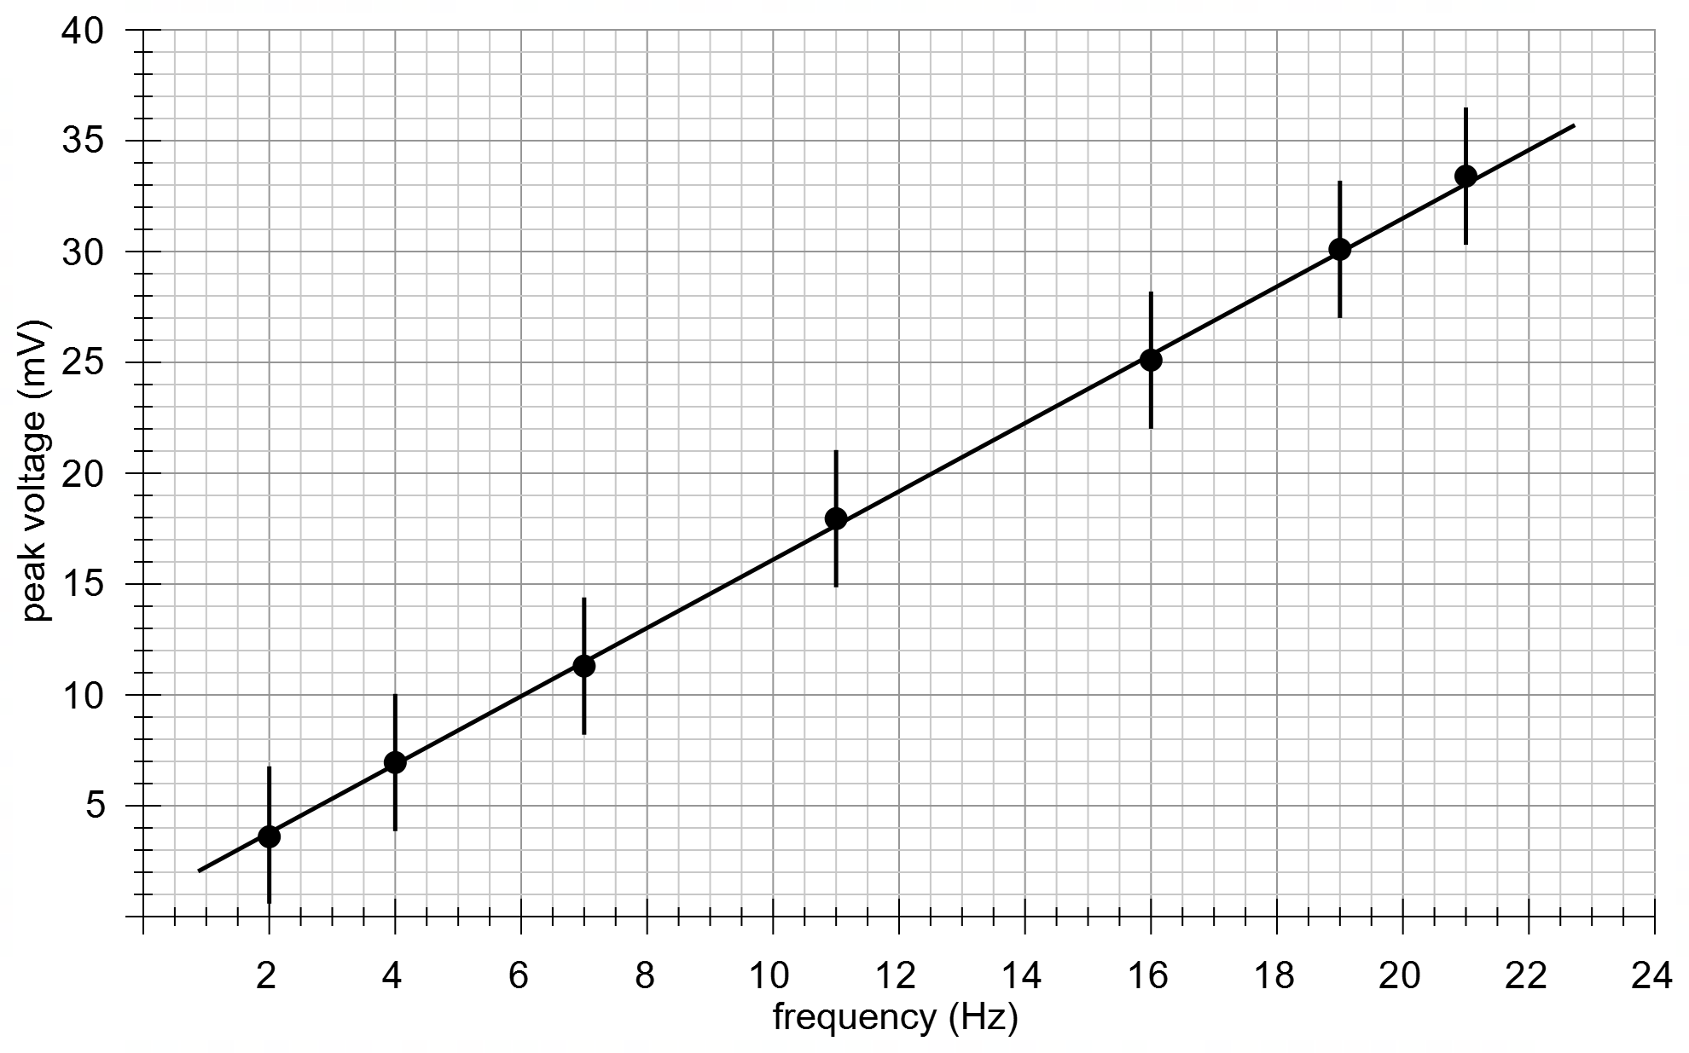

(a) Determine the gradient for the graph above and, using a relevant formula, determine the strength of the magnetic field in the generator. Give your answers to a maximum of two significant figures. (3 marks)

gradient __________________ V s

magnetic field strength ___________________ T

(b) Using the vertical error bars on the graph, use a suitable method to estimate the uncertainty in the magnetic field strength. Give your magnetic field strength to two significant figures and your uncertainty to one significant figure. (4 marks)

magnetic field strength ___________________ ± __________________ T

Question 5 (4 marks)

A forklift is lifting two boxes of fruit of masses 225 kg and 125 kg off the ground, by applying a force F on each fork of the forklift.

125 kg

225 kg

F F

The vertical velocity of the fruit boxes (positive upwards) was measured over the 1.30 seconds it took to lift the boxes to their maximum height and is shown on the graph below.

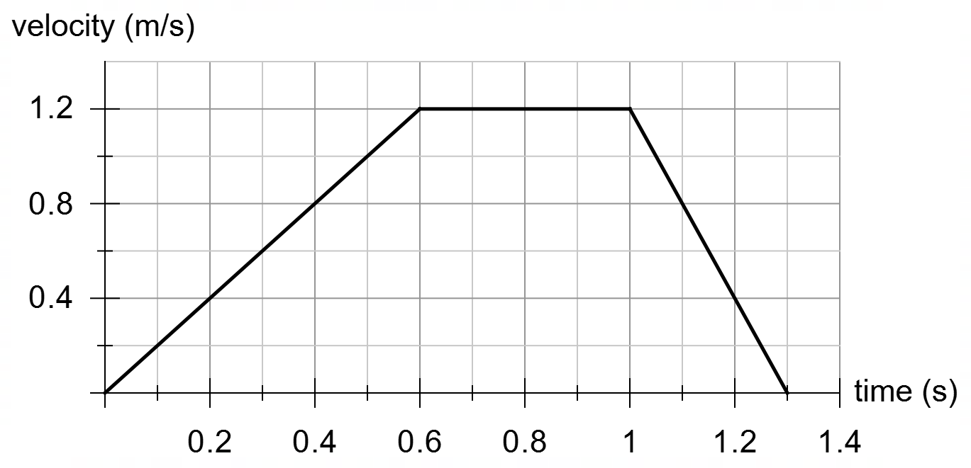

Determine the maximum force F that each fork exerts over the 1.30 s.

max force F ___________________ N

Question 6 (4 marks)

A 255 kg satellite is put into a low Earth orbit at an altitude of 388 km.

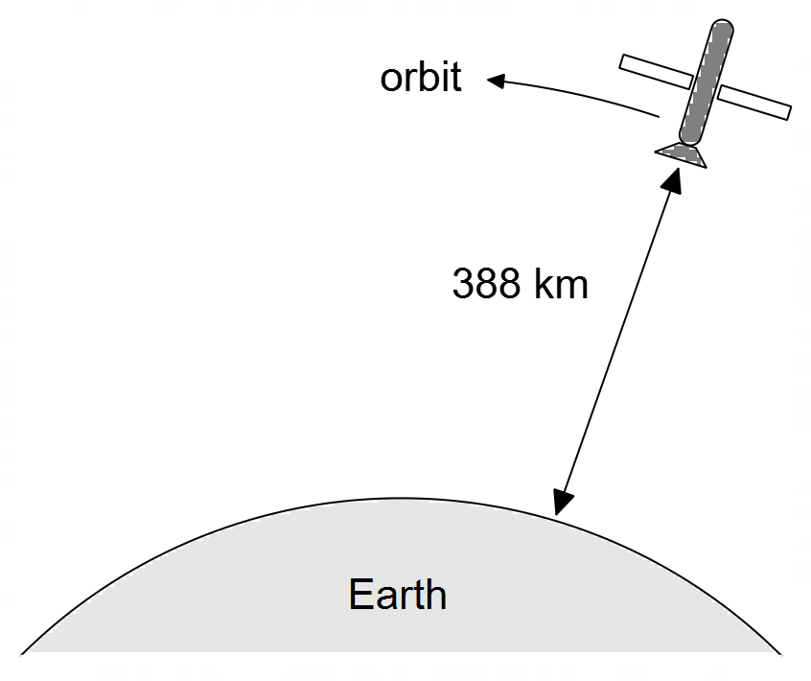

(a) Calculate the orbital speed of the satellite in km s^{–1}. (2 marks)

orbital speed ___________________ km s^{–1}

(b) Calculate the magnitude of the acceleration experienced by the satellite in orbit. (2 marks)

acceleration ___________________ m s^{–2}

Question 7 (4 marks)

The diagram below shows a fence post that is in equilibrium.

Each of the fence wires are in tension T and the support wire is in tension S.

The tensions in the wires are such that the net horizontal force on the post due to the wire is zero.

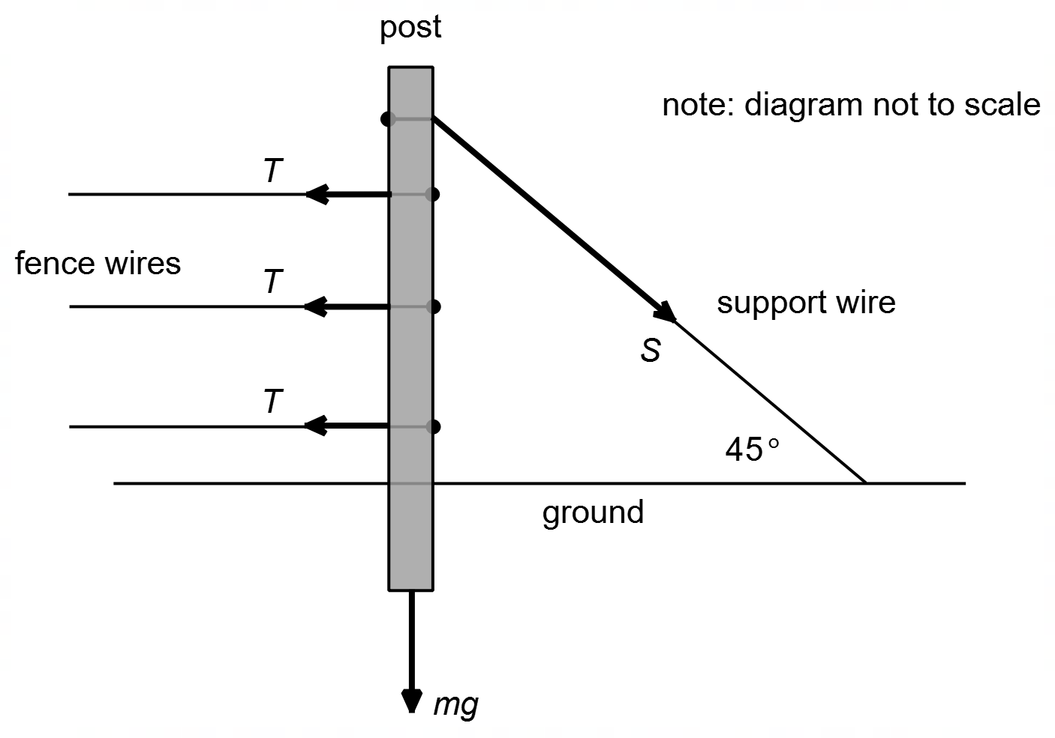

(a) State the direction of the reaction force exerted by the ground on the fence post. (1 mark)

(b) It is noticed that when the tensions in the fence wires are increased, the force exerted by the ground on the fence post also increases. With reference to the conditions required for equilibrium, account for this observation. (3 marks)

______________________________________________________________________

______________________________________________________________________

______________________________________________________________________

______________________________________________________________________

______________________________________________________________________

______________________________________________________________________

______________________________________________________________________

______________________________________________________________________
Question 8 (4 marks)

A Calcium ion (Ca²⁺) travelling in an easterly direction at a speed of 1.335 x 10⁶ m/s in a magnetic field experiences a force of 2.20 × 10^{–14} N to the south. Find the magnitude and direction of magnetic field influencing the Calcium ion. Ignore any relativistic effects.

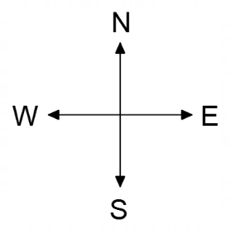

magnitude _____________________ T

direction _______________________
Question 9 (5 marks)

Two charged particles X and Y are 5.30 mm apart. Particle X has an electric charge of +7.48 µC while particle Y has an electric charge of –6.12 nC.

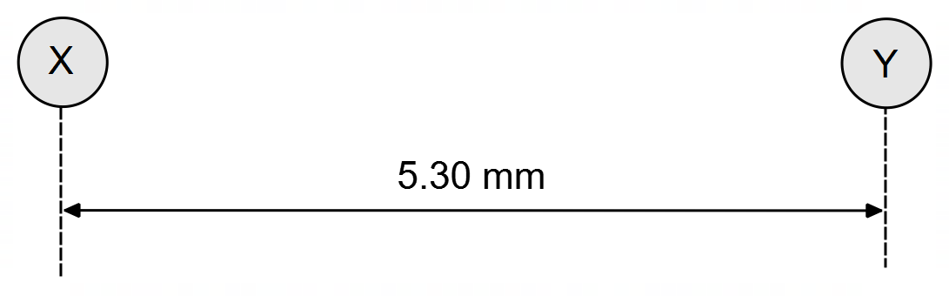

(a) Calculate the magnitude of the force exerted by particle X on particle Y. (3 marks)

force ____________________ N

(b) What is the magnitude of the electric field strength at X due to particle Y. (2 marks)

electric field strength ____________________ N C^{–1}

Question 10 (7 marks)

A mechanic is trying to loosen the nut on a large piece of machinery by placing a 45.0 cm long wrench on the nut in a horizontal position. The nuts require a torque of 775 Nm to loosen. The mechanic has a mass of 67.0 kg.

(a) Demonstrate, with a suitable calculation, that the mechanic is unable to loosen the nut by simply standing on the end of the wrench. (2 marks)

(b) Unable to loosen the nut, the mechanic slides a long metal tube onto the end of the wrench such that the total arm length is now 1.25 m (still in a horizontal position).

(i) Explain how this will make loosening the nut easier. (2 marks)

_____________________________________________________________________

_____________________________________________________________________

_____________________________________________________________________

_____________________________________________________________________

_____________________________________________________________________

(ii) When the mechanic stands on the wrench, starting horizontally, through what angle will the nut rotate before stopping? Assume the mechanic doesn’t slip. Also assume that there is nothing to prevent the wrench from making a complete rotation around the nut, save only the amount of available torque. (3 marks)

rotation angle ____________________ °
Question 11 (6 marks)

A soccer ball is kicked and follows a trajectory through points A – D as shown below. At point A the ball has just been kicked, at B the ball has reached maximum height, at C the ball is at half its maximum height and at D the ball makes maximum contact with the ground (bounces).
Note: the diagram is not to scale.

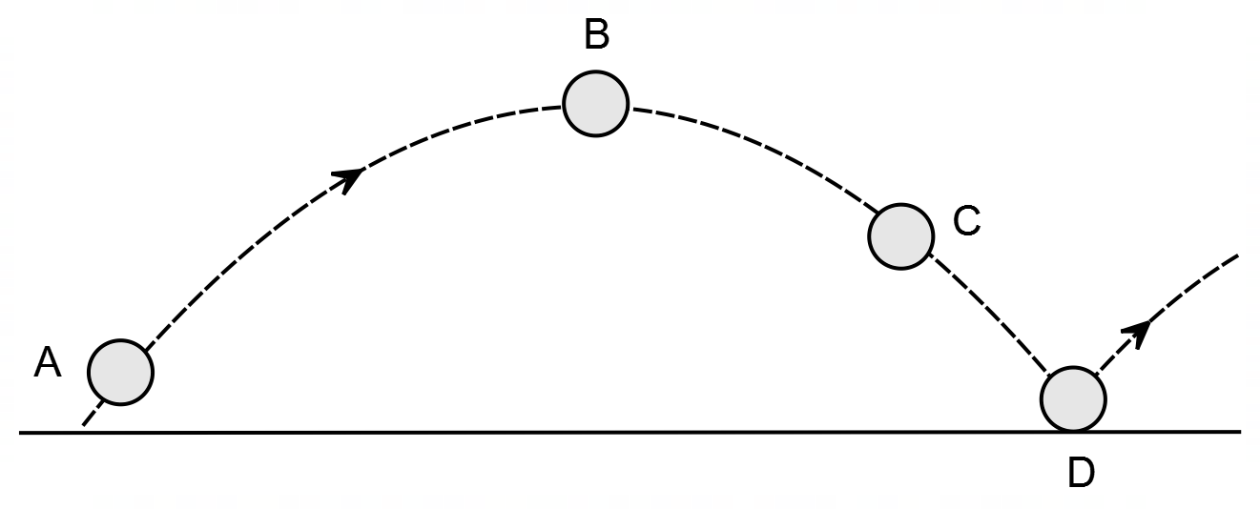

(a) On the diagram, draw a vector representing the net acceleration of the soccer ball at points A, B and C. Ignore friction and air resistance. Clearly label these vectors. (2 marks)

(b) On the diagram, draw a vector representing the net force on the soccer ball at point D. Ignore friction and air resistance. Clearly label this vector. (2 marks)

(c) Assuming that the path of the soccer ball shown on the diagram above involves air resistance, arrange the magnitudes of the net acceleration on the ball at positions A, B and C ($a_{A}$, $a_{B}$, $a_{C}$), in the boxes below. (2 marks)

> >
Section Two: Problem Solving 50% (90 marks)

This section has seven (7) questions. Answer all questions. Write your answers in the space provided.

Suggested working time for this section is 90 minutes.

Question 12 (19 marks)


The diagram below shows a proton travelling through two different electric fields; one in between the horizontal plates in the section marked ‘A’, through which the proton travels with negligible velocity, and another in between the vertical plates in the section marked ‘B’, where the plates are 20cm apart. The sphere Q is neutral, though not grounded, with a radius of 10cm; the proton passes above the sphere at a minimum distance of 4cm after leaving section ‘B’. In section ‘B’ only, there is a magnetic field keeping the proton’s path from deviating; the electric field in this space is solely there to accelerate the proton. The entire set-up is isolated from the effects of any external magnetic fields.
Q
‘A’
‘B’
20cm
4cm

(a) Given that the proton passes through the electric field in section ‘A’ without deviating,
determine:

(i) The polarity of the top and bottom plates in section ‘A’: (2 marks)

Polarity of Top Plate = ___________ ; Polarity of Bottom Plate = ___________

(ii) Draw the electric field between the plates in section ‘A’ on the diagram above: (2 marks)

(ii) The magnitude of the electric field between the plates in section ‘A’: (2 marks)

Electric Field Strength = _________________ N/C
(b) In section ‘B’, the proton experiences a force of 2.0x10⁻¹⁵ N to the right due solely to the
presence of the electric field there.

(i) Find the potential difference between the plates in section ‘B’: (2 marks)

Potential Difference = _________________ V

(ii) Draw the electric field & the magnetic field between the plates in section ‘B’ on the
diagram above. Clearly label which is which: (2 marks)

(ii) Find the speed of the proton at the moment when it leaves section ‘B’ (assume that the
thickness of the plates is negligible): (2 marks)

Speed of Proton = _________________ m/s

Once the proton exits section ‘B’ it passes over the neutral sphere marked ‘Q’, which is connected to an external circuit, allowing it to become charged almost instantaneously. At the moment the proton passes directly above the sphere, for t = 2.89x10⁻⁷ s, the sphere gains a momentary positive charge, repelling the proton with an upward force of 2.02x10⁻¹⁵ N, causing the path of the proton to deviate.

(c) Find the magnitude of the momentary charge on the sphere ‘Q’. (2 marks)

Charge on Q = ____________________ C

(d) Determine the final velocity of the proton. (5 marks)

Velocity = ________________ m/s, at ___________ ⁰ to the horizontal.

Question 13 (12 marks)

The diagram below shows an aluminium ring falling from rest down a smooth wooden rod from position A to position G, as shown. A wire coil surrounds the wooden rod from positions C to E. There is a constant current flowing in the wire coil thus creating a magnetic field in the coil. Ignore any frictional forces between the rod and the ring or between the ring and the surrounding air.

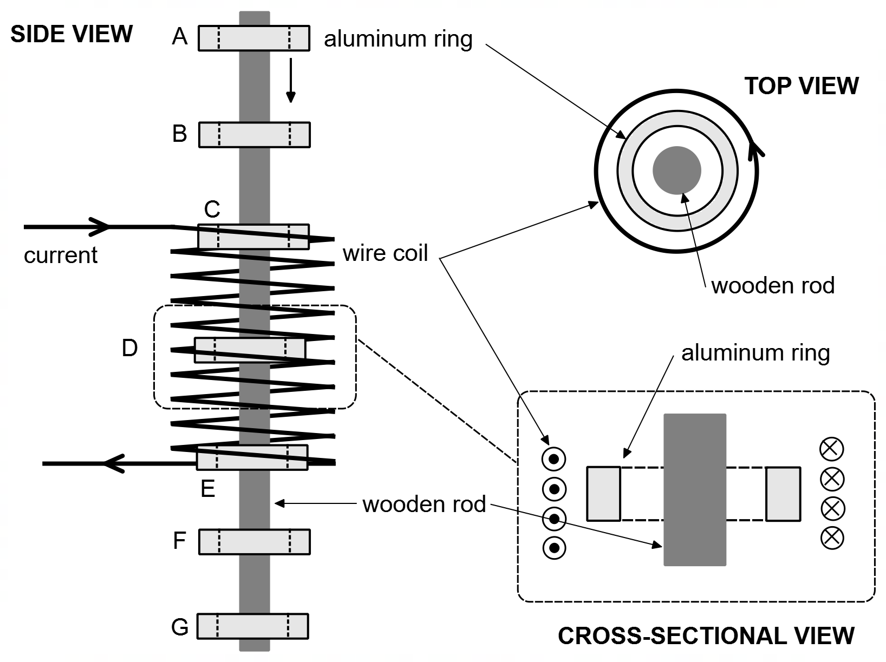

(a) On the cross-sectional view indicate the direction of the magnetic field in the coil due to the current in the coil. (2 marks)

(b) The cross-sectional view below shows the ring at position F. Indicate the direction of the induced current in the aluminium ring, using appropriate symbols (• and ×) for the direction of current, AND indicate the direction of the magnetic field induced in the ring due to the induced current. (2 marks)

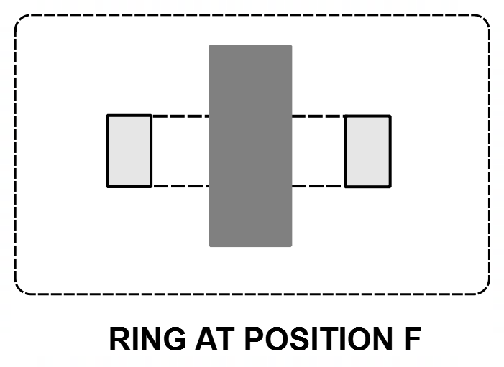

(c) The first graph below shows the variation of the magnetic field experienced by the aluminium ring as the ring moves from position A to position G, along the wooden rod.

Use the information provided to sketch a graph on the set of axes below of the net force on the aluminium ring as it moves from position A to G. Use the sign convention that forces in a downward direction are negative (there is a spare graph at the end of the exam if you make a mistake). (5 marks)
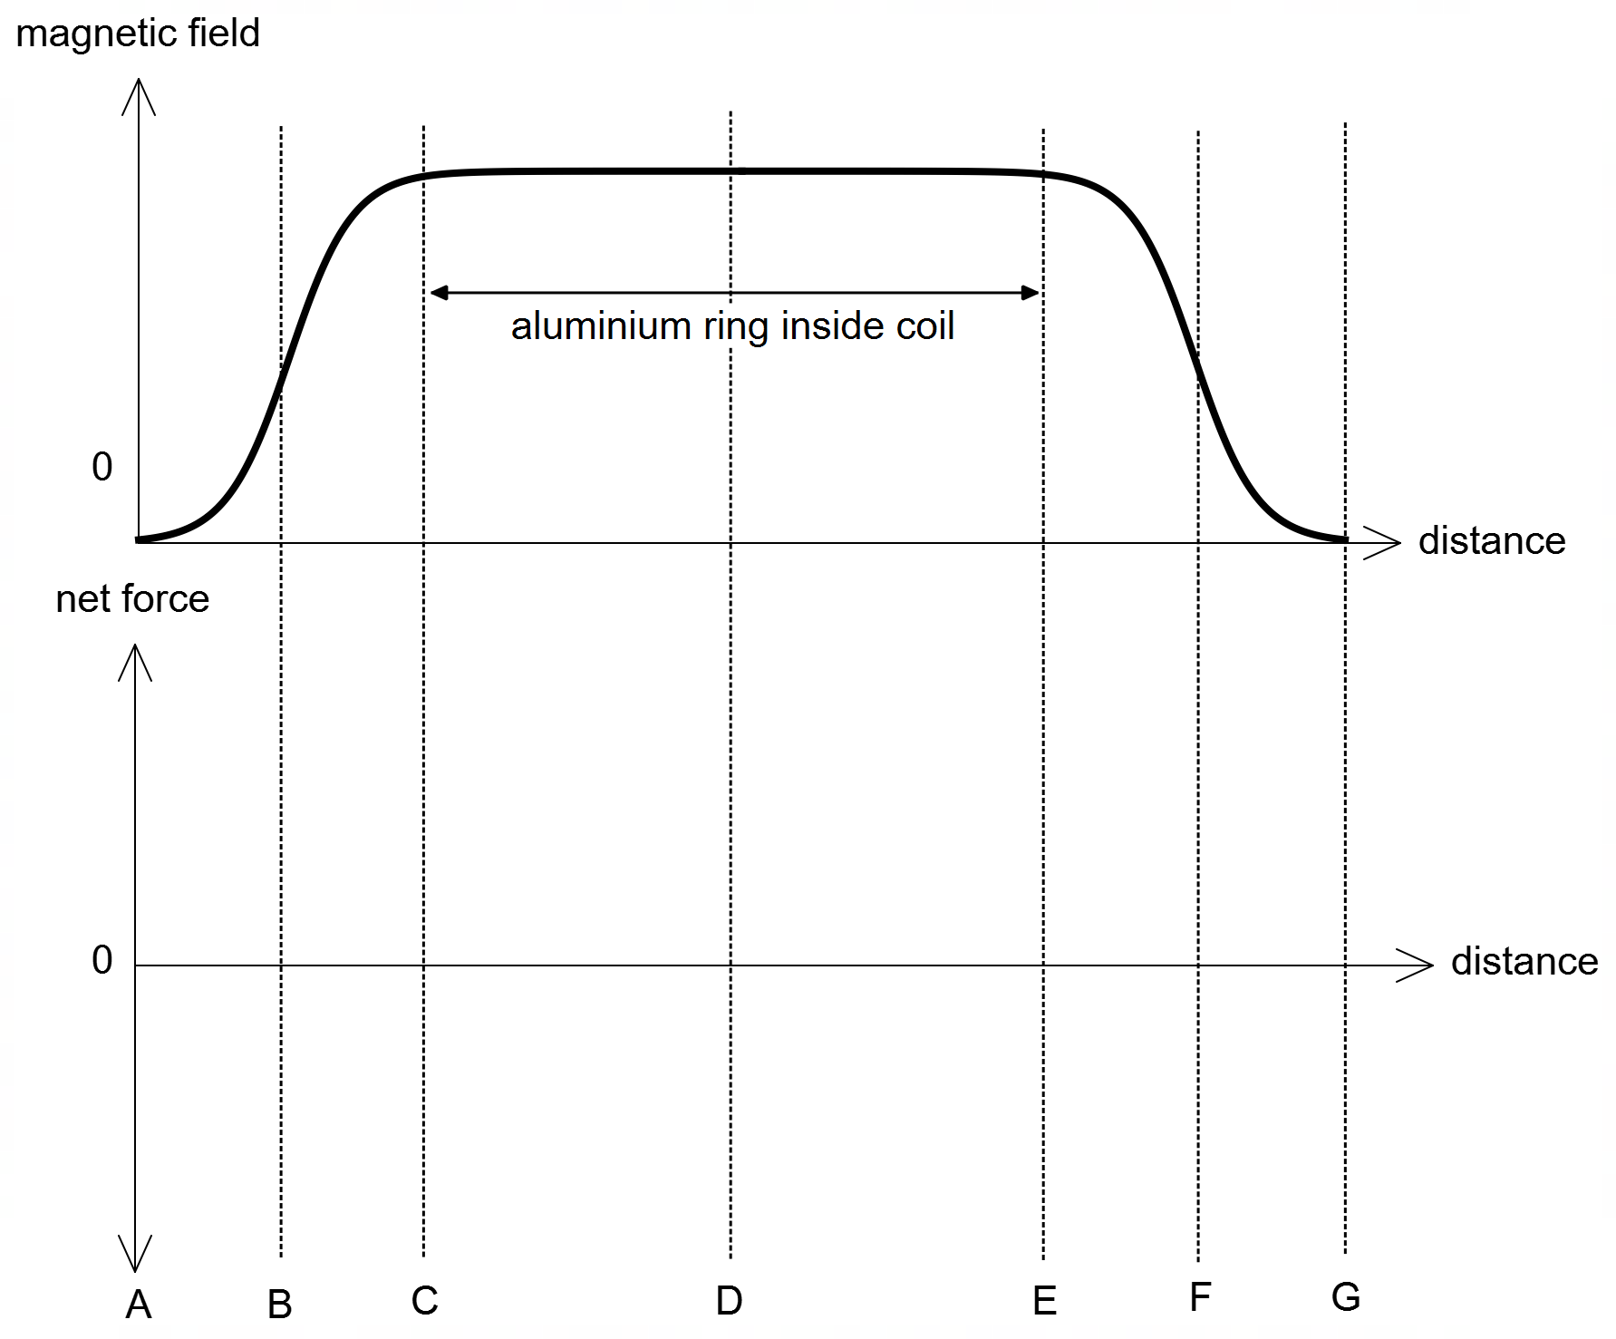

(d) The magnetic constant for wood is 1.26 × 10^{–7} N A⁻¹ (very close to that for a vacuum) while for stainless-steel the magnetic constant is 2.10 × 10^{–4} N A⁻¹. How would using a stainless-steel rod instead of a wooden rod affect the motion of the aluminium ring as it moves from position A to G. Justify your answer with relevant physics. (3 marks)

______________________________________________________________________

______________________________________________________________________

______________________________________________________________________

______________________________________________________________________

______________________________________________________________________

______________________________________________________________________

Question 14 (14 marks)

A tennis ball throwing machine is set up 4.00 m from a vertical brick wall and fires a tennis ball at 12.0 m s^{–1} at 30.0° above the horizontal at a height of 0.900 m off the ground. The ball strikes the wall at point B and rebounds at the same angle (above the horizontal) it struck the wall with. The ball then travels along the projectile path shown until point C, where it is struck by a tennis player.

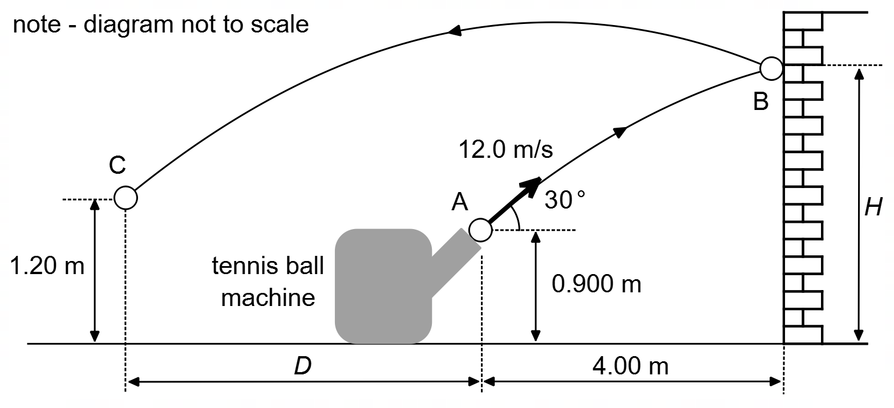

Assuming the collision with the wall is perfectly elastic and ignoring the effects of friction and air resistance, calculate:

(a) the angle to the horizontal the ball strikes the wall at point B. (5 marks)

angle _________________ °

(b) the speed of the ball as it leaves the wall at point B. (2 marks)

speed _________________ m s^{–1}

(c) the height H of the ball at point B. (3 marks)

height _________________ m

(d) the horizontal distance D the tennis player must position themselves at to hit the ball at C.
(4 marks)

distance _________________ m

Question 15 (15 marks)

A student constructed a simple DC motor using a length of wire, a magnet, and a voltage source. The student shaped the wire into a rectangular coil ABCD with 10 turns of wire having dimensions AB = 12.0 cm and BC = 8.00 cm. The coil sits in a magnetic field of strength 0.840 T, is supplied with a 2.75 A current and, from the perspective of point P, rotates clockwise.

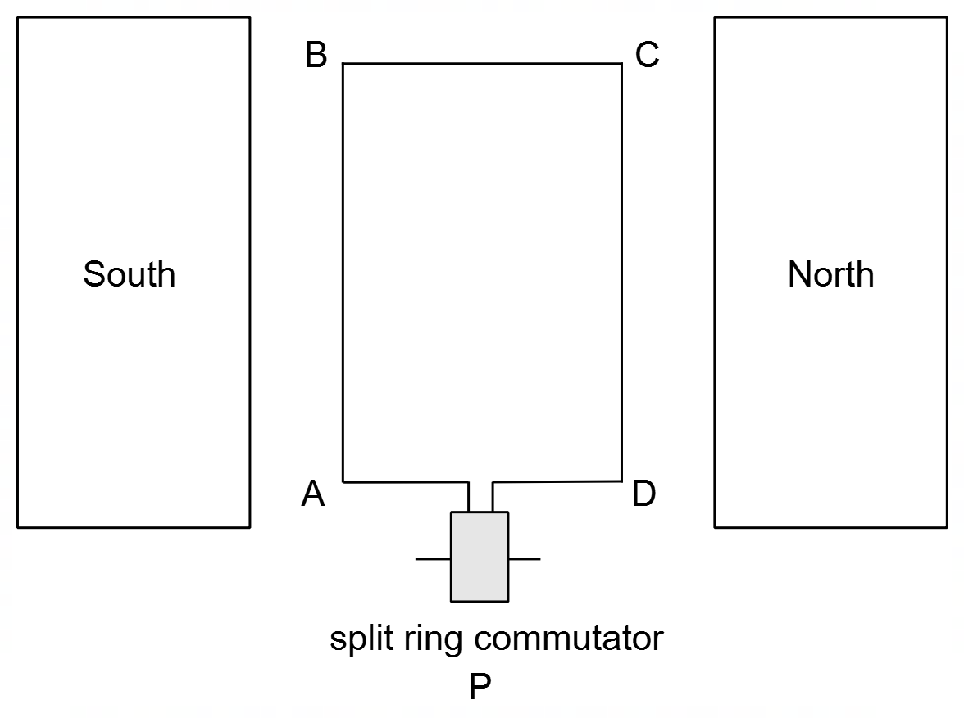

(a) Determine the direction of the current flowing in coil ABCD (as viewed from above) – clockwise or anticlockwise? Circle your answer. (1 mark)

CLOCKWISE ANTICLOCKWISE

(b) Determine the maximum torque generated by the coil. (4 marks)

torque __________________ N m

(c) Spring-loaded Carbon brushes are used to connect the split ring commutator to the external power supply. Explain the two properties that are essential for the Carbon brushes to perform their function: (2 marks)

______________________________________________________________________

______________________________________________________________________

______________________________________________________________________

______________________________________________________________________

(d) The student decided to modify the DC motor and uses a wire of three times the original length and forms it into a similar-shaped rectangular coil as before, but with double the length of AB and double the width of BC. Determine the factor by which the torque produced in this new motor configuration is greater than in the original configuration. You may assume that all the wire is used to make the coils (i.e., ignore the wire to the commutator). (5 marks)

factor ________________

(d) The student got the motor running but noticed that there was a reduction in the net voltage across the coil as it rotated. Further, the student noticed that this drop in voltage increased as the speed of the motor increased. Account for these observations using relevant physics.
(3 marks)

______________________________________________________________________

______________________________________________________________________

______________________________________________________________________

______________________________________________________________________

______________________________________________________________________

Question 16 (14 marks)

A group of cadets are using a rope to slowly lift a 4.20 m long flagpole into a vertical position, by pivoting the flagpole about point P. The cadets at point C simply walk backwards pulling the rope. The rope (of negligible mass) is attached to the flagpole at point A two-thirds up the flagpole. At a certain moment, as indicated, the 9.10 kg uniform flagpole and the rope make an angle of 62.0° and 30.0° with the horizontal respectively and are in equilibrium. A flag of mass 0.755 kg hangs from the end of the flagpole.

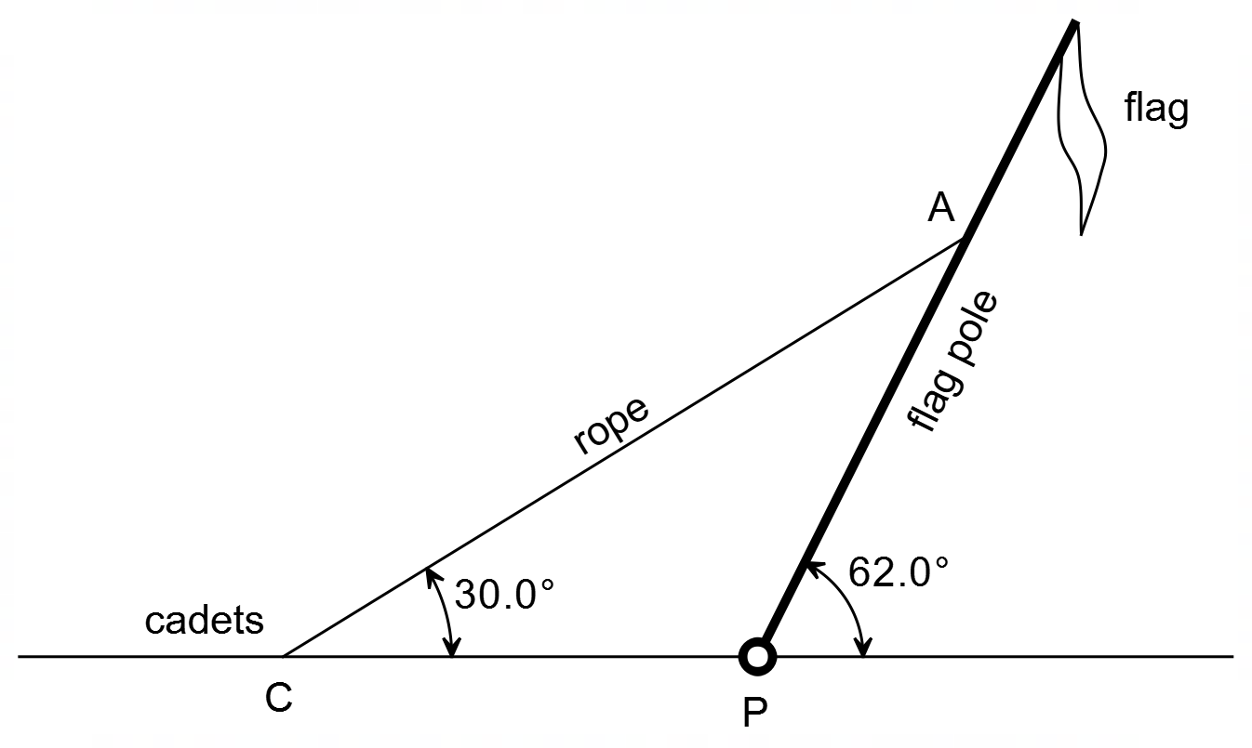

(a) Show that the tension in the rope is approximately 70 N. (5 marks)

(b) Determine the magnitude of the reaction force and the direction relative to the horizontal, of the reaction force of the ground acting on the pivot at point P. Note: if you did not calculate part (a) you may use the value of 70 N for tension in the rope. (5 marks)

magnitude __________________ N

direction/angle ___________________ °

(c) Describe and account for how the magnitude of the tension force in the rope changes as the flagpole is raised closer to vertical. (4 marks)

______________________________________________________________________

______________________________________________________________________

______________________________________________________________________

______________________________________________________________________

______________________________________________________________________

______________________________________________________________________

______________________________________________________________________

______________________________________________________________________

Question 17 (6 marks)

A motorbike and rider of combined mass 230 kg is in horizontal circular motion inside of a spherical cage, which can be modelled as horizontal circular motion on a banked track (see dotted line in diagram). The vehicle has a speed of 14.0 m s⁻¹ and is relying on friction to stay at a fixed height in the sphere. The radius of the circle is 4.0 m. The ‘track’ is banked at an angle of 65.0⁰ to the horizontal. Friction acts from the cage onto the motorbike parallel to the ‘track’ as shown.
Vector Diagram:
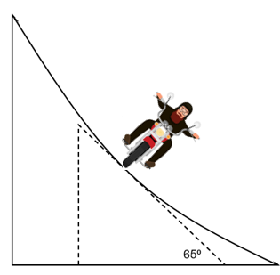
Friction

(a) Construct a vector diagram in the space provided above. Show the forces acting on the vehicle and the net force. (2 marks)

(b) Calculate the magnitude of the friction force acting on the vehicle. (4 marks)

Friction = ______________________ N

Question 18 (10 marks)

A 75.0 kg pilot is flying an aircraft around an airport while waiting to land. The pilot is flying the plane in a horizontal circular path of radius 9.00 km as shown. Each revolution about the airport takes 525 seconds to complete.

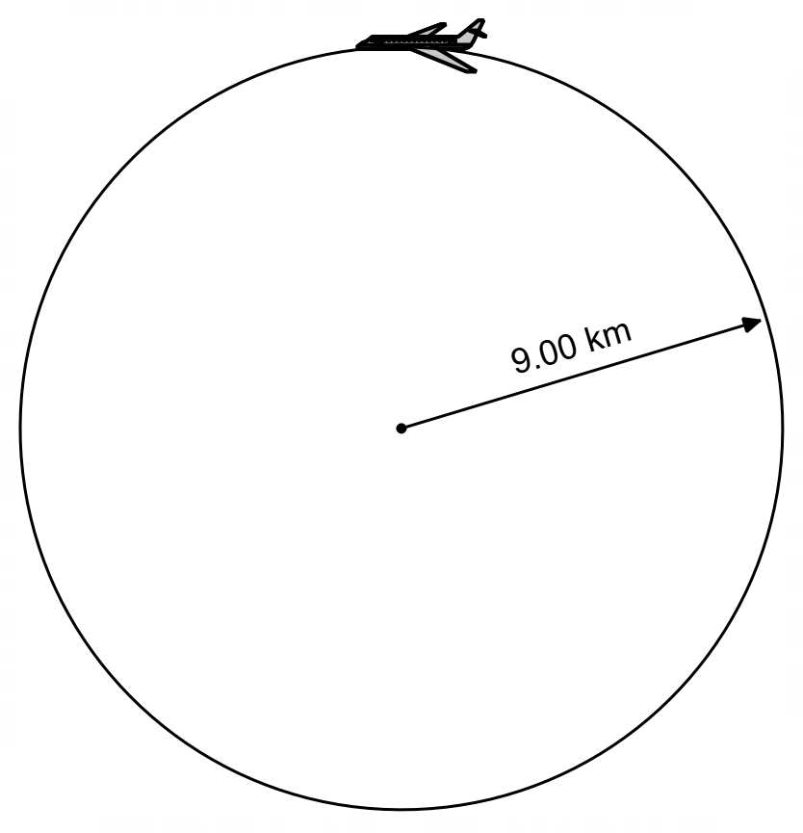

(a) Determine the magnitude of both the centripetal force and centripetal acceleration on the pilot during this horizontal flight. (4 marks)

centripetal force ___________________ N

centripetal acceleration _________________ m s^{–2}

(b) Determine the angle that the plane must bank to achieve this horizontal flight. (2 marks)

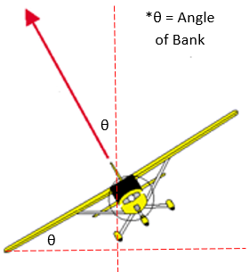

angle __________________ °

As part of the descent of the plane, the plane follows a section of a vertical circular path of radius 1.30 km as shown below to a lower altitude. Note: diagram not to scale.

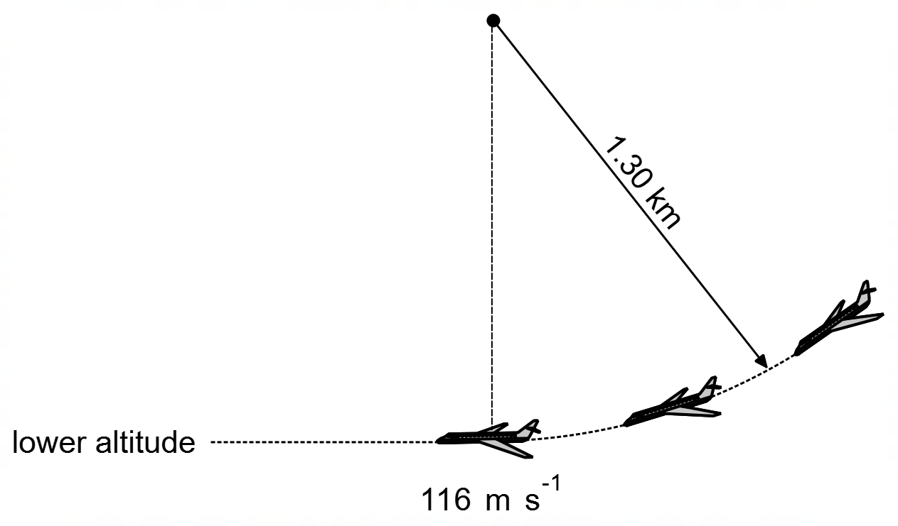

(c) During this descent the plane speeds up to a maximum of 116 m s^{–1} at the bottom. Determine the maximum apparent weight of the pilot during this manoeuvre? (4 marks)

max apparent weight ______________ N

Section Three: Comprehension 20% (36 marks)

This section has two (2) questions. Answer both questions in the spaces provided.
Suggested working time: 40 minutes.

Question 19 (18 marks)

Olympic Discus Throw
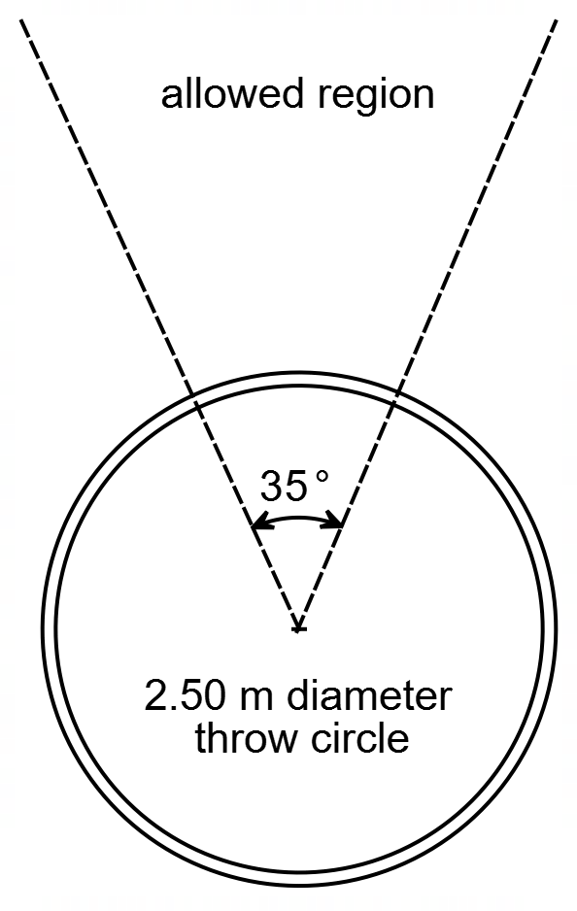
The discus throw is an Olympic event which originated in the pentathlon in ancient Greece around 700 BC and has continued ever since. Early discuses were made of stone, bronze, or iron.
The aim of Olympic discus is to throw the discus as far as possible, within the allowable region. The allowable region is an angular region of 35° from the centre of the throwing circle. The throwing circle is a 2.50 m diameter circle where the thrower must always stay within (Figure 1).
The discus itself is a round thin object, usually made of wood, hard plastic or metal, with a diameter of about 15 – 25 cm, having a mass of 1.00 kg (women) and 2.00 kg (men). Modern discuses have more of the mass located on the outer edge of the discus, rather than in the middle.
The current Olympic record for men’s discus is 69.89 m (2004), and for women’s discus is 72.30 m (1988). However, the longest ever recorded discus throw is 74.08 m (1986).
The thrower begins by facing away from the throw region, holds the discus in one hand and then rotates through one and a half rotations within a circular area of diameter 2.50 m (Figure 1). The thrower then spins around to gain momentum. The athlete must begin with both feet firmly on the ground, then begins to spin, first on one leg, then on the other. This builds up speed, which is translated into momentum for the discus. Finally, the thrower releases the discus into the allowed throw region. From stationary to release, the throwing action takes around one second.
Figure 1 - Discus Throw Area
Figure 2 - Trajectory of discus for various angles
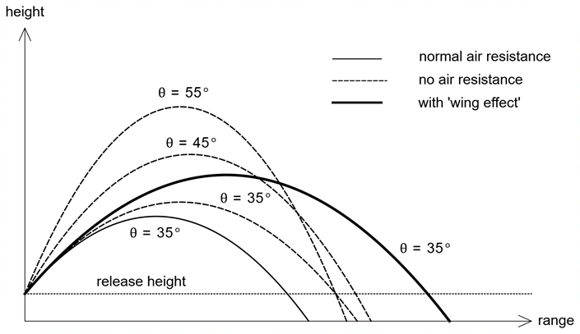

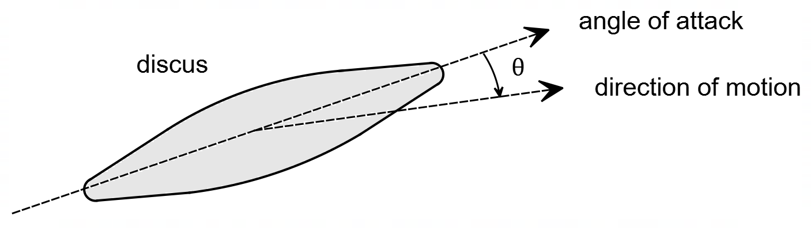
One of the unique aspects of discus is that the discus spins as it leaves the hand of the thrower causing the discus to angle upwards to catch and ride on the wind, thus giving extra lift to the discus, increasing the range of the discus. The ‘angle of attack’ of the discus is the angle the plane of the discus makes with the direction of motion (Figure 3). The lift force acts perpendicular to the direction of motion. The percentage increase in the range of the discus, due to this extra lift, is called the ‘wing effect. The ‘wing effect’ can increase the range of the discus by up to 20%.
Figure 3 - cross section of discus in flight

The drag force due to air resistance always acts in the opposite direction to the motion of the discus. An increased angle of attack and increased speed will result in a higher drag force.
One of the main factors affecting the range of a discus throw is the angle of release. Figure 2 shows the path of a discus for three different angles: 35°, 45° and 55°. The dashed line indicates no air resistance, the solid line with air resistance and the bold line air resistance with the wing effect. The diagram shows the path of a discus thrown at 35° for these three scenarios: normal air resistance, no air resistance and with ‘wing effect’.
The main technique of discus is to ensure maximum release speed, with just the right amount of spin, at just the right release angle. Even with a sufficient spin rate, if the angle of attack is too large the discus will have lots of lift but insufficient horizontal speed and thus “fall out of the sky”.

(a) Explain how the phenomenon of ‘wing effect’ increases the range of a discus. Use relevant physics concepts in your explanation. (4 marks)

______________________________________________________________________

______________________________________________________________________

______________________________________________________________________

______________________________________________________________________

______________________________________________________________________

______________________________________________________________________

______________________________________________________________________

______________________________________________________________________

______________________________________________________________________

______________________________________________________________________

______________________________________________________________________

(b) A certain discus throw has the following parameters: the angle of release is 37.6°, the height of release is 1.66 m, the range of the throw was measured at 69.2 m, and the release speed was 24.0 m s⁻¹. By calculating the expected range (with no air resistance) determine the ‘wing effect’, as a percentage, for this throw? (6 marks)

wing effect ______________ %

(c) Estimate the maximum tension in the arm of an Olympic female discus thrower during her throw. Give your answer to an appropriate number of significant figures. Clearly state your assumptions. (4 marks)

maximum tension ________________ N

(d) The discus below is travelling upwards and has an angle of attack of 10°. On the discus below draw and label the forces acting on the discus. In the dashed box draw a vector diagram, including the net force. Assume that this discus is uniform. (4 marks)

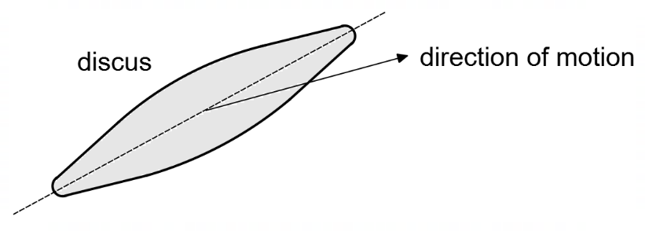
Question 20 (18 marks)

Power from Wind Turbines

Wind power has been around for a while, since the late 1800s. The first recorded wind turbine is in the US in 1888, where a rich aristocrat used it to produce electricity for his mansion. Today wind farms are quite common in many countries around the world. In Australia there are currently 94 wind farms (a wind farm is a collection of large wind turbines), producing a combined power of 16 GW nationally.
The advantages of wind power are that, once the wind turbine is installed, very little input is required from the owner with relatively low operating costs. The wind turbine will spin in consistent wind, spinning the turbine inside the main housing, thus generating electricity. The use of wind is renewable and a clean source of energy.
There are, however, several disadvantages. Wind turbines are quite costly to install and must pass strict environmental criteria. A wind turbine is also dependent on consistent wind speeds to produce enough power and so the location must be carefully chosen. The visual impact (as well as noise pollution) are other factors that must be considered when positioning and designing wind farms.
Figure 4 below shows the main components of a turbine: rotors, nacelle, tower, and foundation.
cross-sectional area $A$
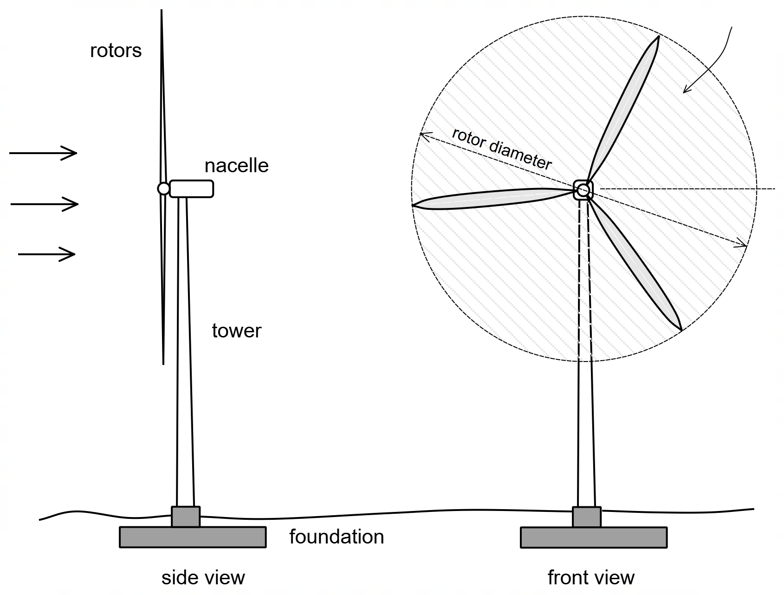

wind velocity $v$

Figure 4 – main components of wind turbine

The rotors (or the blades) are responsible for catching the wind and converting the kinetic energy of the wind into rotational energy of the rotors. The rotors of turbines are also capable of spinning on their axis, angling into or out of the wind. In this way the rotors can catch more or less of the wind, depending on conditions.
The nacelle is the hub like box situated behind the main rotor blades. The nacelle contains a gearbox and generator. The purpose of the gearbox is to ensure that the generator runs at a constant rotational speed of 50 Hz, to generate power at 50 Hz. Therefore, the gearbox will adjust the output speed for the generator to ensure a smooth 50 Hz. The nacelle also houses a brake mechanism which can stop the blades in high, dangerous winds.
The tower is the main upright designed to support the entire turbine ensuring it is sufficiently supported and safely off the ground.
The foundation of the wind turbine is the large concrete footing to which the tower is fastened. The foundation is designed to support the weight of the turbines, nacelle, and tower, but also prevent the toppling or twisting of the tower due to the winds rotating the rotors.
The maximum theoretical power that can be extracted from the force of wind blowing past was found by Albert Betz in 1919 and is given by what has become known as Betz’s law:
$$P_{B}=\frac{8}{27}ρv^{3}A$$
Where $P_{B}$ is the maximum available power (W), $ρ$ is the density of air (kg m⁻³), $v$ the velocity of the air (m s⁻¹) and $A$ the total cross-sectional area of the rotating rotors exposed to the wind (m²). Typically wind turbines only utilise about 60% – 75% of this available energy.
The amount of electrical power generated from a turbine, often referred to as “rms power” or “average power”, $P_{avg}$ is given by:
$$P_{avg}=\frac{1}{2}V_{peak}I_{peak}$$
Where $V_{peak}$ is the maximum voltage generated and $I_{peak}$ is the maximum current generated.
The utility factor of a wind turbine is the ratio of the average electrical power produced to available power: $P_{avg}/P_{B}$.
The most common wind turbine is the 1.50 MW turbine. The following data is a collection of information about some of the key features of this turbine:
Rotor blade diameter 78.0 m
Rated Power output 1.50 MW
Rotor assembly weight 25.0 tonnes
Nacelle weight 42.0 tonnes
Tower width at top 2.20 m
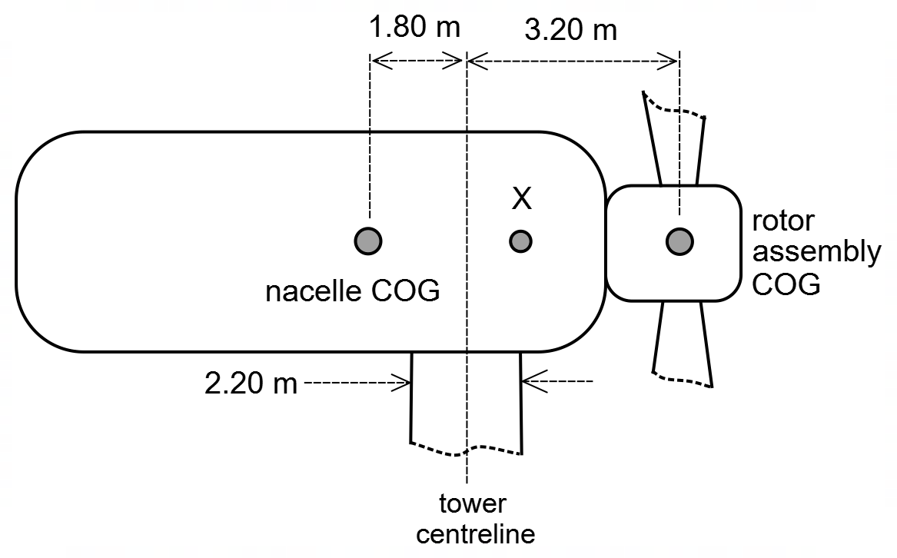
Figure 5 shows the nacelle and rotor assembly components, with their centre of masses located 1.80 m and 3.20 m respectively from the centreline of the tower. Point X represents the centre of gravity of the entire top section (i.e., the nacelle and the rotor assembly).

Figure 5 – nacelle and rotor assembly

(a) List one economic advantage and one environmental disadvantage of wind turbines.
(2 marks)

Economic Advantage ______________________________________________

Environmental disadvantage ______________________________________________

(b) The peak current flowing in a 1.5 MW turbine is 105 A, the strength of the magnetic field is 2.25 T, the coils consist of 315 turns of wire and are formed in a 30.0 cm by 42.0 cm rectangle. Using this information, show that the average power of this turbine is approximately 1.5 MW. (5 marks)

(c) Using Betz’s law, calculate the maximum power which can be extracted from a 1.5 MW wind turbine in winds speeds of 40.0 km h⁻¹ (the density of air is 1.225 kg m⁻³). (4 marks)

power ________________ MW
(d) Using your answer to part (b) and (c) calculate the utility factor of a 1.5 MW wind turbine. (Note: if you didn’t calculate part (b) and/or (c) you may use an average power of 1.5 MW and an available power of 2.4 MW). (1 mark)

utility factor _________________

(e) A simplified free-body diagram of the forces acting on the nacelle and rotor assembly is shown below. By taking torques about a suitable point, calculate the location of point X (the Centre of Gravity for the nacelle and rotor assembly) in relation to the centre line of the tower. Explain what this means in relation to the stability of the assembly. Assume that the reaction force R acts through point X. (6 marks)
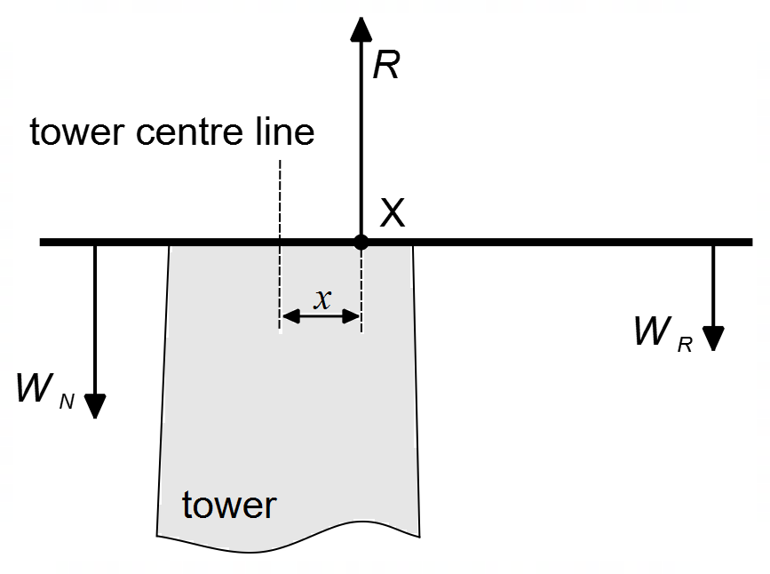

distance $x$ ___________________ m
Explanation
______________________________________________________________________

______________________________________________________________________

______________________________________________________________________

End of Questions

Spare Graph for Question 13



Additional working space

Question number(s): ……………………

Additional working space

Question number(s): ……………………

ACKNOWLEDGEMENTS

Question 19 Information about Discus Throw adapted from Wikipedia contributors. (2021, October 18). Discus throw. In Wikipedia, The Free Encyclopedia. Retrieved 12:41, September 2, 2021, from https://en.wikipedia.org/wiki/Discus_throw

Question 20 Information about wind turbines taken from Wikipedia contributors. (2021, September 1). Wind turbine. In Wikipedia, The Free Encyclopedia. Retrieved, September 11, 2021, from https://en.wikipedia.org/wiki/Wind_turbine

Information about Betz’s law taken from Wikipedia contributors. (2021, March 9). Betz's law. In Wikipedia, The Free Encyclopedia. Retrieved September 11, 2021, from https://en.wikipedia.org/wiki/Betz%27s_law

WATP acknowledges the permission of the School Curriculum and Standards Authority in providing instructions to students.

